Digital Cheques Leveraging Blockchain Technology

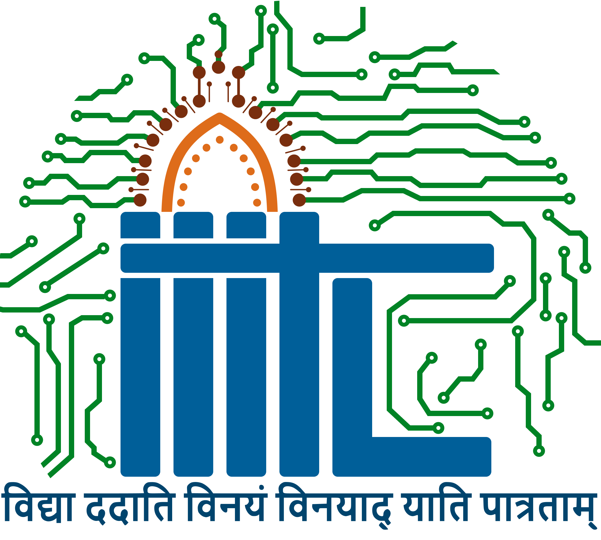

**Submitted to: Professor Vinaya Satyanarayana**

**Date: 12-12-24**

**Group Number: 4**

**Group Members: Narendula Gresshma - LCB 2021018  
Harsh Golchha- LCI 2021002  
Aditya Kumar- MDB23012  
Rohit Dixit-MDB23014  
Abhijit Prasad -MDB23015**

Area of Focus:

**Focus Area:** Financial Services and Payment Systems

**Objective:**

The goal of this project is to transform the present cheque payment system through the integration of the blockchain technology. It aims at major concerns like time consumptions, security concerns, and optimization by converting the cheque-based transaction into a sophisticated system. As a result, it enhances a better structure of the financial world based on it and promotes the development of banking technologies by utilizing blockchain’s inherent features including decentralization, and data integrity.

Business cheques may take anything from two to five working days to clear depending on the forwarder’s traditional methods. Such forms of delays include manual verification that prevents tracking, coordination among different entities, and physical documentation. It eliminates these drawbacks because blockchain ensures a validation process that could take only a few minutes. Another reason that instigates the adoption of blockchain is the improvement of security. Cross cheques are some of the certain hitches that include forgery, theft and loss within the cheques during transit. Blockchain removes these issues owing to its cryptography and means of decentralized records. Also, activities that allow manual data input and data validation are likely to cause actual human errors. Automation reduces these challenges because Blockchain has the capability to automate most processes.

**Rationale:**

Nonetheless, cheques continue to be popular and accepted to a certain extent in several countries because of the current advance method of payment known as digital payment systems. However, they rely on the physical documentation and have their verification processes centralized, and therefore may be exposed to fraud and many inconveniences. Blockchain de-synchromizes this age old system by digitizing it. The resulting digital cheques are in many ways superior to paper hybrids as they are faster, more secure ,and more accessible in general, and correspond to the general trend of moving towards digital solutions. In addition, the above project empowers its users, implementing products for people or group segment such as Individuals, SMEs, and corporate users. This innovation is in harmony with one of the sectoral visions of developing a wide-ranging Digital Economy.

2. Idea Description

The proposed Blockchain-Based Digital Cheque System leverages blockchain’s core features—decentralization, immutability, and cryptographic security—to create a robust and efficient framework for cheque transactions. By adopting this innovative approach, the system transcends the limitations of traditional methods, paving the way for a transformative financial service.

**Key Features:**

Time Efficiency: Transactions are validated in real-time, eliminating the need for days-long

clearance processes. A digital cheque can be issued, accepted, and

processed within minutes.

Enhanced Security: Every e-cheque is signed with cryptographic keys and is stored in a decentralised, tamper resistant database to reduce risks related to forging of signatures or loss of physical cheques.

Smart Contracts: Like electronic funds transfer, cheques can be written with certain conditions attached such as a date after which the cheque will be pounded, or certain conditions required for encashment of the cheque, and these are automatically adhered to without the need for a third party.

Traceability: Each transaction has its own crypto unique ID which enables issuers and

The system enables the tracking of its status on the recipients in line with the current real-time status.

Blockchain's inherent traceability enables users to track the status of their transactions in real-time, fostering transparency and trust. Finally, the user-friendly design of web and mobile applications ensures accessibility for users across different demographics, promoting widespread adoption and satisfaction. By integrating these features, the system creates a comprehensive solution to longstanding challenges in cheque transactions.

3. Domain Understanding

Current Value Chain and Pain Points:

The traditional cheque clearing process involves several steps and inherent inefficiencies that contribute to delays, security risks, and high operational costs. Below is a detailed breakdown of the process and its associated pain points:

Steps in Traditional Cheque Clearing Process:

* Issuer Writes a Cheque and Provides it to the Recipient: The process begins with the issuer filling out a cheque and handing it over to the recipient. This physical exchange of a paper instrument is inherently slow and subject to logistical delays.
* Recipient Deposits the Cheque at Their Bank: The recipient physically delivers the cheque to their bank. This step may involve travel to a branch, queuing, and waiting for a teller to process the deposit. In some cases, ATMs or mobile banking apps can facilitate this step, but physical submission is still a widespread practice.

The current cheque clearing process involves multiple steps: when the issuer writes the cheque, the recipient deposits it and the cheque can then be taken to a clearinghouse for verification. In this model, the clearinghouse works in cooperation with the authorized issuing bank on the availability of funds before transferring the funds to the beneficiary’s account. This process, although is logical, it is very inefficient due to time lost, possibility of fake certificates and loss of documents, and manual errors caused by the paperwork.

This means that through the use of the blockchain based system the validation and recording of the transactions that would have been coordinated by the clearinghouse are eliminated. This makes it possible to transform the time taken in day’s to just a few minutes, bring about better security due to a record that can hardly be altered and also brought about reduced costs to the financial institutions involved. Furthermore, it brings openness that allows issuers and receivers to track the cheques at Release 1.

4. Geography and Regulation

**Geography of Operation: India**

The system has been developed to function under the Indian legal and technological framework alongside the existing and projected legislations provided through the RBI and MeitY. Digital payment systems and financial instruments are regulated by the RBI with help of regulatory frameworks, for instance, PSP Act, 2007. On the other hand, the Ministry of Electronics and Information Technology (MeitY) supporting blockchain as a part of Digital India also gives a favorable condition to apply it.

The RBI’s Payment Vision 2025 also shows the opportunity to apply innovative developments in digital banking for this project in a suitable environment that is regulated at the present stage. However, there are issues that have to be addressed, for example, legal requirements on processing personal data, and admissibility of cryptographic signatures. Solving these issues will require the successful incorporation into existing laws and regulation, and commitment to continuous regulation compliance updates.

5. Technology

Blockchain Frameworks

* Ethereum for Smart Contracts and Decentralized Processing: Ethereum is one of the most widely used public blockchain platforms, designed to support decentralized applications (dApps) and smart contracts. The Ethereum Virtual Machine (EVM) executes smart contracts, ensuring reliability and immutability.
* Decentralization: Ethereum allows for a distributed ledger system where transactions are validated and recorded by multiple nodes, reducing the risk of tampering or fraud.
* Smart Contracts: These are self-executing contracts with predefined rules written in Solidity, the programming language for Ethereum. They handle operations like cheque issuance, expiration, and maturity autonomously.

Hyperledger Fabric for Private, Permissioned Ledgers

Hyperledger Fabric is ideal for enterprise applications requiring privacy and controlled access. Unlike Ethereum, it supports permissioned networks, making it suitable for sensitive financial transactions.

* Modular Architecture: Fabric’s modular design allows for the customization of consensus mechanisms, identity management, and data storage, tailoring the system to banking requirements.
* Privacy: Sensitive information, such as account details or cheque terms, can be securely managed through Fabric's channel architecture, ensuring only authorized parties access specific data.
* Endorsement Policies: Transactions are validated based on pre-agreed endorsement policies, ensuring compliance with regulatory requirements.
* Interoperability: Fabric supports integration with existing banking infrastructures, enabling seamless communication between blockchain networks and traditional systems.

Smart Contracts

* Automating Cheque Rules: Smart contracts serve as the backbone of blockchain-based cheque systems by automating the processes surrounding cheque handling.
* Cheque Maturity: Smart contracts enforce the maturity date of a cheque, ensuring that funds cannot be withdrawn before the specified date.
* Expiration: Contracts automatically invalidate cheques past their expiration date, reducing the risk of misuse or confusion.
* Recall Mechanism: Issuers can recall a cheque under certain conditions, provided these are predefined in the smart contract. For instance, if a cheque is lost or issued in error, the contract could trigger a recall mechanism.
* Conditions for Fund Release: Smart contracts validate and execute fund transfers based on specific conditions, including:
  + Verification of the recipient’s identity using cryptographic methods.
  + Confirmation of sufficient account balance on the issuer’s side.
  + Validation of cheque authenticity and compliance with issuance rules.
  + This automation eliminates manual errors, reduces processing time, and ensures a tamper-proof execution of agreements.

APIs

* Integration with Banking Systems: Application Programming Interfaces (APIs) are essential for bridging the blockchain-based cheque system with traditional banking infrastructure.
* Fund Transfers: APIs facilitate real-time transfer of funds from the issuer’s account to the recipient upon successful verification.
* Account Validation: APIs verify account details, ensuring that both issuers and recipients are legitimate and compliant with banking regulations.
* Seamless User Experience: APIs provide a seamless interface for users to interact with the blockchain system while maintaining the functionality of conventional banking platforms.
* Automated Notifications: APIs enable automated notifications, informing users of cheque issuance, deposit, and settlement statuses, enhancing transparency.
* Data Security: API security protocols like OAuth 2.0 and TLS encryption ensure secure communication between blockchain systems and banking networks. These safeguards protect sensitive information from unauthorized access or interception.

Cryptographic Keys

* Secure Identity Verification: Blockchain systems use asymmetric cryptography for secure identity verification. Each participant (issuer, recipient, or validator) has a pair of cryptographic keys:
* Public Key: Acts as the unique identifier visible to all participants.
* Private Key: Used to sign transactions and prove ownership, ensuring authenticity. For example, when a cheque is issued, the issuer digitally signs it using their private key, and the recipient verifies it using the issuer’s public key.
* Protecting Cheque Data: Cryptographic methods ensure that cheque data, such as amount, maturity date, and recipient details, are encrypted and stored securely on the blockchain. Only authorized parties with the correct keys can decrypt and access this information.
* Immutable Records: Every transaction involving a cheque is recorded immutably, preventing any unauthorized alterations.
* Multi-Signature Schemes: In some cases, multiple private keys may be required to authorize a transaction, adding an extra layer of security.

The frontend, which can be reached by web and mobile applications with a simple interface, the middleware layer working with API gates for the interaction, and the backend based on the blockchain and smart contracts systems for transactions. Such an architecture is also scalable, fault-tolerant and meets the needs of various types of users.

6. Customer and User Behavior

**Target Users:**

* Individual Users: Secure Personal Transactions

The service is the one that caters for people who need a safer way of performing their transactions. Cheque clearing techniques in the traditional banking models may undertake manual work, cause a delay in processing, and may be susceptible to cheques forgery. Through this system, it is possible for people to perform transactions fast, and these transactions are characterized by enormous security since performance and accountability are provided by the blockchain feature. This is so beneficial to users in particular for those who may need to make payments without having to visit bank physically.

* Small Businesses: Faster Payment Settlements

One, cash flow management and timely receipt of payments are potentially significant problems for many small business. Clearing checks after some days may inconvenience the business and may also cause tension between the business and its supplier or partner. It is employed so as to optimise payments clearing for small business that may otherwise be bogged down by other form of non value added processes. Thus, the ability to clear cheques more quickly means that small enterprise can positively adapt their financial operations and improve productivity.

* Large Enterprises: Bulk Cheque itself is a mechanism to issue cheque but with an added advantage of automated processing.

To the large enterprises, the handling of these volumes of cheque can be a tiresome affair that demands much effort. Accuracy, reductions in the risks of fraud or errors –these type of traditional approaches are often lacking within the high volume processes. This system provides an opportunity for cheque processing and is an effective solution that cuts across time and creates minimal opportunities for mistakes. Features such as single click import and automated matching are convenient used by large businesses in handle their financial transactions quickly and securely.

**Value Proposition**

Time Savings: Fast processing was being done in minutes compared to days in the past.

It also reduces the duration it takes to process cheque in the service by a very huge percentage. In traditional models there are various stages like manual checks and physical transfer of cheques, all of which can take several days. This system has important advantages for users because the processing takes nearly zero time. This enhancement is specially important to those operations and persons who have to rely on timely receivables for their financial health and functioning.

For example, a small business which has to wait for a cheque to be cleared is likely to be affected by its operations since it has no cash. Such a problem is solved by the system which takes minutes to process the transaction and makes the financial handling problem free.

Security: Permanent and Auditable Transaction Digital Records

Security is one of the fundamental considerations of the service. Every transaction is written down in a clear and unchangeable record of transactions making the data accurate and easy to track. This feature reduces the risks associated with fraud, tampering, and errors that characterize most of the cheque processing systems. The platform provides real-time tracking of all users’ transactions so clients can feel the security of the service.

In the case of the financial institutions, the measures of increasing the security provide protection against fraud incidences and hence minimum expenses required to counter the influences as well as improve the customer’s trust. The second of its benefits is that this security feature also assists with adherence to industry standards for regulation, creating still one more line of defense for all shareholders.

Convenience: Puts an End to Physical Bank Runs

The essence of the system unveiled is digital which means that users do not physically go to physical banks. Customers are also able to enter, manage and monitor transactions directly from their homes or offices. This convenience is particularly beneficial in scenarios such as:

* People, who are handling their money in their absence.
* SME’s that require to make use of cheques without having to close shop for sometime in the process.
* Those companies that clear many payments at once in different branches or offices.

The primary users of the Blockchain-Based Digital Cheque System include individual users seeking secure personal transactions, small businesses aiming to expedite payment settlements, and large enterprises requiring bulk cheque issuance with automated processing. By addressing the unique needs of these segments, the system offers a tailored value proposition for each group.

Individuals benefit from reduced processing times and enhanced security, while small businesses experience improved cash flow management and convenience. Large enterprises can automate complex payment workflows, saving time and reducing operational costs. The pricing structure supports accessibility through nominal transaction fees and subscription plans, catering to diverse financial capabilities and usage patterns.

7. Market and Strategic Analysis

Market and Strategic Analysis: A Detailed Review

The Blockchain-Based Digital Cheque System is positioned within a rapidly evolving financial services market, driven by digitalization and technological advancements. This innovative solution introduces a blockchain-based approach to transform cheque transactions, addressing the inefficiencies of traditional systems. By understanding its competitive environment, leveraging strategic tools like Porter’s Five Forces and SWOT analysis, and identifying key challenges and opportunities, the project is well-positioned to achieve market success. Below is a comprehensive explanation of the market and strategic analysis in the context of the proposed system.

Competitors:

The financial services market is teeming with established digital payment providers like Paytm, Razorpay, and other global platforms such as Google Pay and PhonePe. These competitors have significantly influenced consumer behavior and raised the standard for digital payment solutions, offering seamless transactions, low costs, and user-friendly interfaces.

While these platforms excel in areas like instant money transfers and digital wallets, they primarily focus on real-time digital payments and lack specific solutions for cheque-based transactions. The Blockchain-Based Digital Cheque System, on the other hand, addresses this niche by incorporating blockchain technology to modernize cheque clearing. It stands out by offering enhanced security, programmability, and traceability—features that traditional digital payment platforms do not inherently provide.

This differentiation presents a significant opportunity to carve a unique niche in the financial ecosystem, particularly for businesses and individuals who continue to rely on cheques for various reasons, including legal or contractual requirements.

**Porter’s Five Forces Analysis**

To assess the competitive environment and market viability, the Porter’s Five Forces framework provides valuable insights:

* Threat of New Entrants – Low
* Regulatory Barriers: New entrants face significant hurdles due to the stringent regulatory landscape governing financial services. Compliance with regulations on cryptographic signatures, data privacy, and payment system interoperability adds complexity.
* Technical Complexity: The development and integration of blockchain technology into banking systems require expertise and resources, which act as entry barriers for smaller players.
* Trust and Reputation: Financial transactions rely heavily on user trust. Building credibility in a market dominated by established players requires substantial investment in security and customer acquisition.
* Bargaining Power of Buyers – High
* Users, including individuals, SMEs, and large enterprises, demand secure, cost-effective, and efficient solutions. Their bargaining power is heightened by the availability of alternative digital payment platforms.
* The Blockchain-Based Digital Cheque System must address these demands by offering unique features like real-time processing, transparency, and enhanced security to remain competitive.
* Bargaining Power of Suppliers – Moderate
* The system relies on technology providers, blockchain developers, and financial institutions for infrastructure and implementation.
* Collaboration with reliable partners and the use of scalable, open-source blockchain platforms like Ethereum and Hyperledger Fabric can mitigate supplier dependency.
* Threat of Substitutes – Moderate to High
* Substitutes include digital payment methods like UPI (Unified Payments Interface), NEFT (National Electronic Funds Transfer), and RTGS (Real-Time Gross Settlement), which provide instant transfers.
* The system’s blockchain-enabled features, such as programmability and cryptographic security, must be marketed as superior advantages to mitigate substitution threats.
* Industry Rivalry – Moderate
* While the competition from digital payment providers is intense, there are few direct competitors offering blockchain-based cheque solutions.
* This relative lack of direct rivalry provides the system with a first-mover advantage in addressing the niche of digitalized cheque transactions.

**SWOT Analysis**

The SWOT analysis identifies internal strengths and weaknesses, as well as external opportunities and threats, providing a holistic view of the system’s potential.

Strengths

* Enhanced Security: Blockchain’s immutable and cryptographic features ensure tamper-proof transaction records, reducing risks of fraud, forgery, and data breaches.
* Efficiency: By automating cheque clearing processes, the system reduces transaction times from several days to just minutes.
* Scalability: The system is designed to handle large transaction volumes and diverse user segments, from individual users to large enterprises.

Weaknesses

* High Initial Development Costs: Building the blockchain infrastructure and integrating it with existing banking systems require significant investment in technology and expertise.
* Learning Curve: Adopting blockchain-based solutions may be challenging for users unfamiliar with the technology, requiring investments in education and user support.

Opportunities

* Rising Digital Adoption: Emerging markets like India are witnessing a surge in digital payments, supported by government initiatives like Digital India and RBI’s Payment Vision future.
* Expansion Potential: The system can extend beyond cheque transactions to support other financial instruments and cross-border payments.
* Strategic Partnerships: Collaborations with banks, fintech companies, and blockchain consortiums can accelerate adoption and expand market reach.

Threats

* Regulatory Challenges: Compliance with evolving laws and standards for blockchain-based financial services could pose operational risks.
* Competing Payment Systems: Established digital payment providers may enhance their offerings, leveraging their market presence to compete directly.

Strategic Implications and Competitive Advantages

Differentiation Through Blockchain:

The system’s use of blockchain provides a unique value proposition, addressing security, efficiency, and transparency in cheque transactions. By leveraging smart contracts, cryptographic signatures, and real-time tracking, the system offers features that traditional cheque clearing methods and digital payment platforms lack.

Targeted User Segments:

The system caters to diverse user segments:

* Individuals: Benefit from secure personal transactions without the need to visit physical bank branches.
* Small Businesses:Experience improved cash flow management through faster payment settlements.
* Large Enterprises: Streamline bulk cheque issuance and processing with automated workflows.

This segmentation ensures tailored solutions for various market needs, enhancing user satisfaction and adoption.

Regulatory Alignment: Aligning with India’s legal framework and the RBI’s Payment Vision 2025 positions the system as a compliant and forward-looking solution. Addressing regulatory hurdles proactively, such as data privacy and cryptographic signature validation, will build trust and facilitate integration with existing financial systems.

8. Funding and Risks

To design, implement and continuously evaluate the system about $500,000 will be needed. The initial months are occupied by the creation of the prototype, including six following this period, three months for pilot implementation, and three more for the complete launch. Some of the potential partners for blockchain integration are banks who may need integration, Fintech startups who may be required to develop apps and blockchain consortium who may need resources from other organizations.

The first customers are going to be the trading organizations in the e-commerce and retail business that often need to make prompt payment settlements. The above targets also include financial institutions that would wish to transform their cheque clearing. By identifying the right allies and the possible risk factors, the project moves on towards becoming the next big thing in the market.

This project reawakens the whole word of cheque transactions by applying the blockchain technology, and solve the problems and shortcomings, and provide a better and more secure way and lower cost service. This not only improves the finance operation but also complements the future vision of digitalization of the economy.

**9. Conclusion:**

The Blockchain-Based Digital Cheque System proposed is a huge advancement in the progression of the improvement of the iterative services of funds and the systems of payments. This solution eliminates problems that have been associated with cheque clearing process in the past, including delay, insecurity and hence offer a new approach to handling cheque transactions in the modern world. With the help of fundamental features of blockchain such as decentralisation, non modifiable data, cryptographic method and programmability the system increases efficiency of operations besides providing optimised customer experience to individuals, small businesses and coporate houses.

The enhancements like real-time processing, smart contracts, and traceability alter cheques from basic paper-based methods into efficient, safe, and electronic payment methods. Substantial time saving down, higher security and convenience are the corner stones of the service that will bring more and more user and different demographic and business class. Also, the assess for compliance with the policies as well as its capability of adhering with the legal policies of India and also the readiness to suit with certain policies of India’s digital transformation like RBI Payment Vision 2025.

Tactically, this innovation situates itself as a software-based digital payment solution in an industry where most of its competitors in the market are digital payment gateways or carriers with obvious advantages in terms of security, openness, and programing interfaces.

**References:**

1. Reserve Bank of India: Guidelines for Digital Payments – www.rbi.org.in

2. MeitY: Blockchain Use Cases – www.meity.gov.in

**ChatGPT Usage**

Prompts Used:

1. Explain how blockchain can improve cheque processing.

2. Generate a detailed blockchain-based solution proposal.

3. Create a SWOT analysis for a blockchain financial startup.